**United States**

David Gelman

Max Goplerud

**Abstract**

This chapter analyzes the trends in speaking behavior in the United States Congress from 1921 to 2010 in the House and Senate. We find that key determinants of political behavior from the existing American and comparative literature (seniority, committee chair, party leadership, ideological extremism, and majority party membership) correspond to more floor speeches by members. Senators deliver more speeches per member than their counterparts in the House, although the determinants of activity are broadly similar. Splitting the results by historical period and examining the relationship by the polarization of the chamber show that the effect of certain variables has changed considerably over time. In the House in particular, the effect of committee chair, extremism and majority party status have increased over time while the effect of seniority has noticeably decreased in the post-Gingrich period.

**Keywords:** legislative speech, institutional politics, legislative behavior, Congress, United States

# Introduction

Congressional scholarship is rife with work on committees, roll call votes, and the introduction and passage of bills, all gleaned from the *Congressional Record*, the daily verbatim record of Congress. However, students of Congress have typically thrown away the majority of the substance of the *Congressional Record*: the floor speeches of members of Congress. Since 1885, when Wilson published *Congressional Government*, our understanding of Congress has dramatically increased. What has not changed is the relevance of Wilson's admonition that "Congress in session is Congress on public display, whilst Congress in its committee-rooms is Congress at work"" (Wilson 1885, 79). The assumption that underlies this attitude is that speech does not matter. Yet the overwhelming length and prominence of the *Congressional Record* points to a different reality.

Congressional scholars have long said that time is a member's most precious resource (Cavanagh 1979; Connor and Oppenheimer 1993; Davidson et al. 2013; Fenno 1978; Hall 1996; Langbein and Sigelman 1989). Members of Congress (MCs) each allocate their time differently; previous research on congressional behavior has looked in depth at various activities including roll call voting, committee work, party activity, and electioneering. In contrast, research on floor speech has been limited in both subject and scope. Most research on congressional floor speech is concerned with analyzing "unconstrained" floor time such as one-minute and five-minute speeches and special order addresses in only a handful of Congresses (Harris 2005; Hill and Hurley 2002; e.g. Maltzman and Sigelman 1996; Morris 2001; Rocca 2007). Others have looked at the deliberative quality of congressional speech in limited circumstances (e.g. Connor and Oppenheimer 1993; Taylor 2012; Wirls 2007).

The study of congressional floor speech is part of a broader research tradition that examines how members participate in Congress. Most research on Congress has focused on other kinds of floor activity such as such as on roll call voting (Clinton, Jackman, and Rivers 2004; Cox and Poole 2002; McCarty 2001; Poole 2005; e.g. Poole and Rosenthal 1985, 1991, 2007; Poole et al. 2008; Snyder and Groseclose 2000) or bill introduction and co-sponsorship (Burstein, Bauldry, and Froese 2005; e.g. Cooper and Young 1989; Kessler and Krehbiel 1996; Koger 2003; Wilson and Young 1997; Woon 2008). Still others have considered the role of committees (e.g. Fenno 1973; Gamm and Shepsle 1989; Gilligan and Krehbiel 1987, 1990; Krehbiel, Shepsle, and Weingast 1987; Maltzman 1998; Sinclair 1986; Weingast 1989; Weingast and Marshall 1988), leaders (Cooper and Brady 1981; Jenkins and Stewart 2012; Owens, Schraufnagel, and Li 2016; e.g. Ripley 1967; Sinclair 1983; Strahan 2007), and parties (Aldrich and Rohde 2000a, 2000b; Aldrich, Berger, and Rohde 1999; e.g. Brady, Cooper, and Hurley 1979; Cox and McCubbins 2005, 2007; Krehbiel 1993; Rohde 1991). Yet relative to these well researched subjects, our understanding of member speech is severely underdeveloped.

This chaper seeks to address this problem by systematically examining the determinants of floor speech. We extend existing research by expanding the type of speeches studied (all speeches versus a particular kind) as well as covering a much longer historical period (ninety years versus a handful of Congresses).

Research on floor speech in the United States Congress has previously been restricted to analysis of non-legislative ("unconstrained") floor activity or to only a limited period of study (and often both). In the House, so-called "unconstrained" floor time is made available to members in the form of one-minute speeches, five-minute speeches, and special-order addresses. The essential difference between "constrained" and "unconstrained" floor time is that "constrained" floor time is governed by the normal procedural House rules while "unconstrained" floor speech operates under the same rules of decorum, but not procedure.[1] Maltzman and Sigelman (1996), Morris (2001), and Harris (2005) all confine their analysis to a single Congress (the 103rd, 104th, and 101st respectively). Rocca (2007) increases the period of study to cover the 101st to 106th Houses. Pearson and Dancey (2011) investigate one-minute speeches and floor debate on landmark legislation in the 103rd and 109th Congresses. This research shows that various aspects of congressional life may influence members' propensity to engage in "unconstrained" floor speech.

The reason prior research has typically ignored analyzing all congressional speech and instead chosen to focus on "unconstrained" speech is not immediately obvious. Maltzman and Sigelman (1996) explain their decision to look only at "unconstrained" speech by claiming that because of the tight control exercised on most bills, only "unconstrained" speech is a true reflection of members' preferences over when to make speeches. We disagree, noting that as Maltzman and Sigelman (1996)'s own results show, the decision to take to the floor does not occur in a vacuum. Morris (2001) notes that his work focuses on "unconstrained" speech because a) Maltzman and Sigelman (1996) do so and b) there is a higher likelihood of observing a partisan effect when members are guaranteed uninterrupted television coverage of their speeches. The notion of using both kinds of speech, even in the European parliamentary context, is relatively recent, with Proksch and Slapin (2012) being one of the first to do so.

We leverage a newly available data source from Hein Online and Gentzkow, Shapiro, and Taddy (2018) that contains the full text of the Congressional Record from 1873 to 2010 parsed by speaker.[2] We believe we are the first authors to use this dataset to explicitly analyze the political and institutional determinants of legislative speech in the United States Congress in a broad historical perspective.

Our results both partially confirm the existing literature from Europe on the determinants of speech but also provide a variety of new areas for future exploration. On the confirmatory side, we see a similar effect in terms of members with particular institutional roles (committee chairs), party leaders, and more senior members being more likely to take the floor. Broadly, these results hold across both chambers and across the duration of data we consider.

We examine how these effect change as Congress has become more polarized. Our historical coverage allows us to see a movement from highly heterogeneous parties (e.g. in the middle of the Twentieth Century) to highly polarized ones in the present day. We find that some of the effects of political determinants of speech intensify with polarization. Specifically, we find that the effect of majority party increases and seniority decreases with polarization in the House, but not the Senate. We suggest this may be attributable to the more majoritarian norms in the House but exploring these results is an important area for future research. Overall, however, the effects are rather mixed suggesting a need for further exploration and theory in this area.

# Institutional and Party System Background

The bicameral United States Congress serves as the legislature of the tripartite federal level of government in the United States characterized by a separation of powers across the legislative, executive, and judicial branches of government. The legislature is tasked with the power of the purse, passing legislation, declaring war, and confirming executive appointees (including members of the judiciary). Congress also maintains the power of impeachment and removal of members of the executive and the judiciary.

Members of the Senate and the House of Representatives are chosen in direct elections in single member districts using plurality, first-past-the-post elections. Senators (two for each of the 50 states) are elected every six years while the 435 Representatives are divided among the states according to population determined by a decennial census with each state guaranteed at least one Representative. In regards to the American party system, it conforms to the institutional expectations laid out by Duverger (1963) with two dominant political parties, Republicans and Democrats controlling almost all seats in Congress.[3] The electoral system provides numerous incentives for members of Congress (MCs) to regularly travel back and forth between their home districts and Washington, D.C. Both Mayhew (1974) and Fenno (1977, 1978) detail how Congressional institutions support members’ goals and district level conditions impact the types of strategies that members pursue to attain these goals.

Since each chamber of the legislature may enact its own rules of procedure, the parties act as the originators of the rules that govern their members' behavior. The majority party strictly rules the House while the Senate operates with far less strict majoritarian principles. Given this framework, it is hardly surprising that the parties tend to proscribe procedural rules that safeguard their own power to whatever extent possible. When a new Congress convenes, one of the first orders of business is the passage/adoption of chamber rules. These rules often reflect the key concerns of the majority party at the start of the congressional term, with power likely to be centralized or distributed among members depending on party cohesion and electoral constraints (Aldrich and Rohde 2000a; Rohde 1991).

For this analysis, we only focus on the first Congress following universal adult suffrage in the United States (67th Congress; 1921-1922) as this both provides some comparability to the entire time series as well as including the Senate only after the introduction of mandatory direct election.[4] We also split the data for all analyses into three periods to allow for more fine-grained analysis of whether there are changes in speaking behavior across time. First, we consider the period from 1921-1947 ("Historical"; 67th-79th Congresses) as representing both the pre-World War Two Congress as well as before the major institutional reforms to the House in the Legislative Reorganization Act of 1946. Both the war and the legislative reforms that followed it are a natural break point in American political development and institutions. Second, we lump together most of the Post-War period (1947-1994; 80th-103rd Congresses) to examine broad trends over a long historical period. This also coincides with the “textbook Congress” – the post-war period characterized by near total Democratic Party dominance of Congress and the basis for seminal work on the US Congress. Finally, to ensure comparability with other chapters, we separate out the final period ("Modern"; 1995-2010, 104th-111st Congresses) as this corresponds to Congress post the Gingrich "Revolution" when the Republicans gained control of the House for the first time in decades. Upon gaining control of Congress in 1994, Republicans enacted a number of reforms, including d a variety of structural and institutional changes that affected both floor access (Aldrich and Rohde 2000a) and, presumably, the determinants of speaking behavior (see Taylor 2012).

# 

# The Institutional Setting of Legislative Debate

A key question when studying legislative debates is how do members gain access to the plenary floor to deliver speeches; Proksch and Slapin (2015) provide a comparative scheme used elsewhere in this volume where countries are ranked on two extremes: (a) "parties draw up their own lists and thereby control which members of their party take the floor" or (b) "a nonpartisan figure, usually the Speaker of the House …, recognizes the right of individual members to speak" (p. 79). In this scheme, they classify the United States as falling into the latter (b) where "there is ample empirical evidence that floor participation is unregulated" (p. 44). This categorization accurately characterizes the "unconstrained" speaking time analyzed in the prior research cited above (e.g. Maltzman and Sigelman 1996).

However, we note that a large portion of *legislative* debates occur under a "constrained" system and the rules are rather different. Given that our analysis includes all debates and thus the large amount of activity under the constrained system, it is important to outline the rules governing such debates. We briefly outline the procedural rules for each chamber.

## 

## *House of Representatives*

Access to the floor is closely guarded in the House and strictly governed (Palmer 2010). During debate there are restrictions on the length of overall debate, length of debate on amendments in Committee of the Whole. Most legislation is considered under suspension of the rules, which limits the total debate to forty minutes (Davis 2019) and suspend standing and statutory rules for the purpose of considering legislation that enjoys broad support in the chamber (Hudiburg 2019). Additionally under suspension of the rules, half of the time set aside for debate of that particular matter is reserved for the member making the motion and half by the ranking member of the committee with jurisdiction over the issue at hand (Davis 2019). These two members yield portions of their allotted time to other members to speak to the bill or resolution under consideration. This gives these individuals considerable *de jure* power to control which other members access the floor and thus likely raises the strategic considerations outlined elsewhere (e.g. Proksch and Slapin 2012). The procedural power over who and what makes it to the floor is also a key component of the cartel theory of Cox and McCubbins (2005) with this gate keeping power serving as a direct tool of party leadership to control the agenda.

In the House, access to the floor for the purpose of non-germane speech making is subject to prerogative of the Speaker and includes non-legislative debate in the form of one-minute speeches, special-order speeches, and morning hour debates (i.e. "unconstrained" time). While more fully formalized by the adoption of Reed's Rules in 1890, this norm stretches back to the 1st Congress (Taylor 2012). Furthermore, there is no possibility of a House member holding the floor for greater than an hour's time (Davis 2019), at least under the normal rules of the House. For this reason, much legislative debate happens in the Committee of the Whole (CotW). Some issues, such as those dealing with taxes and spending, are required by House rules to be discussed in the CotW (Davis 2019). In the CotW, there exists a norm of limiting debate to a single hour, with floor managers each controlling half the allotted time (Davis 2019). Further rules exist governing the debate over amendments. Each member is allowed five minutes for each offered amendment (this is known as the five-minute rule) (Davis 2019).

## *Senate*

Members of the Senate face far fewer gatekeepers in their pursuit of floor time, as well as fewer restrictions upon the duration for which a member can keep the floor once it has been attained (Taylor 2012). However, more recently, the right of initial recognition has been used to limit the time available to Senators to gain the floor in the first place (Taylor 2012). Another limit on Senate debate is the rule stating that a Senator may only speak twice on the same question on the same legislative day—though this is rarely enforced (Heitshusen 2019). Perhaps the most notable limitation on Senate debate is cloture, also known as Rule XXII. When passed by the required sixty votes, cloture ends open-ended debate and begins a thirty hour clock, minus time for the roll call votes and quorum calls (Heitshusen 2019). Each Senator is permitted no more than an hour of time, and guaranteed at least ten minutes of floor time (Heitshusen 2019).

Another difference in access to the floor lies in the nature of the presiding officer. While the presiding officer in the House is the Speaker, in the Senate, the president pro tempore has much more limited powers. Specifically, unless a Senator is holding the floor, any Senator has the right to be recognized, and the presiding officer cannot, by rule, arbitrarily ignore one Senator in favor of another (Heitshusen 2019). Thus, overall, the United States Senate appears to be closer to the pole of "individual-centered" access to floor debates.

# 

# The Role of Intra- and Inter-Party Politics in Debate

We begin our empirical analysis by addressing by first showing a number of overall descriptive trends in legislative speech in both the House and the Senate. For our analysis, we rely on the data provided by Gentzkow, Shapiro, and Taddy (2018) that cleans and parses the Congressional Record from 1873 to 2010.[5] From there, various summary statistics can be constructed.

In all analyses reported in this chapter, we focus on the number of speeches delivered by each member in a Congress (two-year period). We also only consider speeches with at least fifty words to maintain comparability with other chapters in this volume. The number of words spoken by each member in those speeches is highly correlated with the number of speeches (.88) and thus we only focus on the number of speeches for simplicity.

We first show a number of descriptive figures on the evolution of speech over time and its relationship to certain demographic and institutional variables. Figure 1 shows the distribution of the (logged) number of speeches across each chamber. It shows that the (logged) amount of activity per member has remained broadly stable—with the median member delivering about 66 speeches per Congress. Senators speak more than members of the House (median of 287 speeches vs 51), perhaps reflecting the fact that there are fewer members to deliver speeches on the legislative agenda. It is worth noting, however, that the distribution of speeches is extremely skewed with some members delivering thousands of speeches per Congress.

**Figure 1: Total Activity**

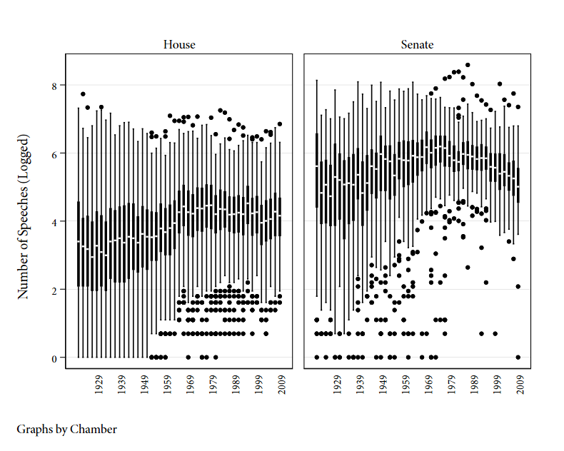

*Note*: This figure shows the distribution of the number of speeches by members in each Congress. The scale is logged. The horizontal bar indicates the median (logged) number of speeches. The (logged) inter-quartile range is shown by the solid box.

Next, we report two sets of descriptive results on gender and seniority. For each, we give a brief synopsis of the existing results from the US literature to contextualize, while referring readers to the theoretical expectations in the earlier chapters to understand the implications from a comparative context.

*Gender*: First, we examine the role of gender. Research shows that women in Congress outperform their colleagues in both securing federal funding for their districts and in the number of bills they sponsor (Anzia and Berry 2011). In an analysis of one-minute speeches and debate of important legislation in the 103rd and 109th Houses, Pearson and Dancey (2011) has also pointed to a gender-driven difference in propensity to participate in floor speech. Karpowitz, Mendelberg, and Shaker (2012) show that women speak more as their proportion in a given legislative group increases. We expect that the effect of being female should increase participation in floor debate, consistent with other research on the effect of gender on participation in the House and explanations of why women need to speak more to overcome the bias against female members.

Figure 2 shows the proportion of speeches versus the proportion of members by gender separated by party, chamber, and the historical periods noted earlier. A major qualification in interpreting the results is that should note that the number of female legislators is very low in the older periods (especially Historical; pre-1945) and thus those results should be interpreted carefully. Broadly, however, there does appear to be a gender gap in activity—especially in the Senate. Interestingly, in the modern period (1995-2010), the gender gap appears to have vanished and women are speaking in roughly the same proportion as their number in the chamber. We will return to this in the regression analysis when other possible confounders are controlled for and the greater activity of female legislators appears to have somewhat more support in the modern era.

**Figure 2: Gender**

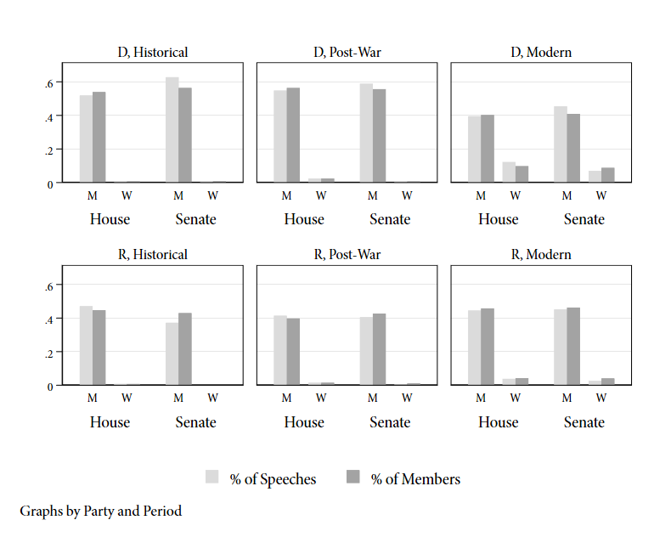

*Note*: This graph shows the proportion of speeches and members across men ("M") and women ("W"), party, chamber and historical period. If the light gray bar is below the adjacent dark gray bar, this implies that this group (e.g. women in the modern Senate) speak less than their share of the members. The data is grouped into three periods as outlined in the main text: Historical (1921-1946), Post-War (1947-1994), and Modern (1995-2010) and shown separately.

*Seniority*: Next, more senior members are hypothesized to make more floor speeches than junior members. Increased familiarity with procedure along with a norm of apprenticeship in Congress (Matthews 1959) means that more senior members should have easier access to the floor and greater opportunity to make floor speeches. Sinclair (1989, 1998) points out that this tradition of the textbook Congress began to wane in the 1960s and through the 1970s; this suggests that the effect may decline in the more recent datasets. The work of Maltzman and Sigelman (1996) and Morris (2001) on one- and five-minute speeches in more recent Congresses shows empirical evidence of these changes. We hypothesize that more senior members will talk more, both because of their increased expertise and knowledge of the floor as well as institutional norms.

We first examine the proportion of speeches given by members of varying levels of seniority (number of terms in Congress) and gender, where we collapse all members who served at least five terms into a single category (4+). We see that, in all periods and in both chambers, freshman ("0") speak less than more senior representatives. As members become more senior, they deliver more speeches but parity is only reached for relatively senior members suggesting a highly unequal allocation of speaking time found in other democracies. The same broad pattern is replicated across both chambers, with junior members in both the House and Senate being outspoken by their more senior colleagues.

**Figure 3: Seniority**

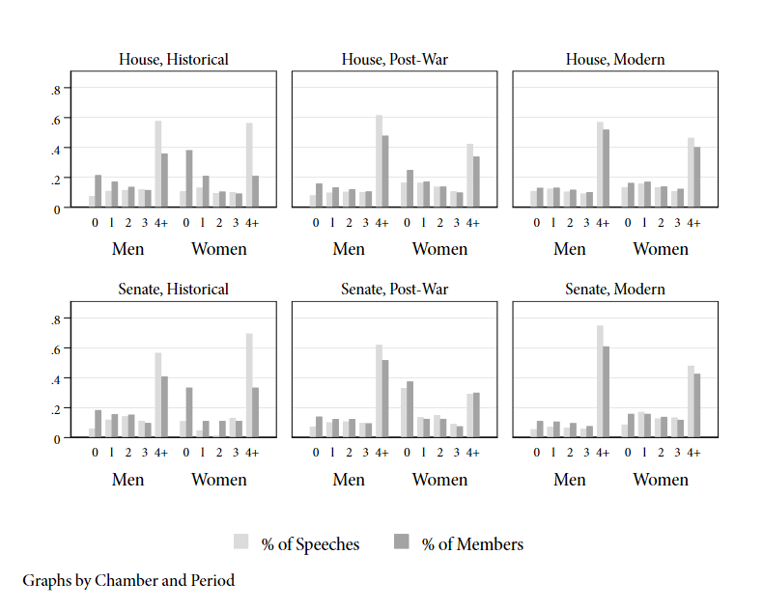

*Note*: Seniority is defined as the number of Congresses (two-year increments) served. If the light gray bar is below the adjacent dark gray bar,this implies that this group (e.g. freshmen ["0"] in all periods) speak less than their share of the members. The data is grouped into three periods as outlined in the main text: Historical (1921-1946), Post-War (1947-1994), and Modern (1995-2010) and shown separately by gender. All members serving at least five Congresses (ten years) are grouped into the "4+" category.

## *Multivariate Analysis of Number of Speeches*

To test these results more formally alongside the role of other variables, this section conducts a regression analysis with various institutional and political variables included as controls. We briefly explain the explanatory variables included in addition to the two variables (gender and seniority) from before.

*Ideological Extremism*: We expect that ideologically extreme members talk more. Maltzman and Sigelman (1996), looking at one- and five-minute speeches and special order addresses in the 103rd House and Morris (2001), analyzing one-minute speeches in the 104th House, find that more extreme members talk more when given unfettered access to the House floor. Gelman (2017), looking at the proceedings of the Federal Convention in 1787, finds ideologically extreme members are more verbose. Even in a much more general setting, we expect that members further from the chamber median deliver more speeches. We measure ideology using the first dimension of the Nokken-Poole scores (Nokken and Poole (2004)) to avoid assuming a linear time trend in ideology; we define ideological extremism as the absolute distance from the chamber median.

*Majority Status*: We expect members of the minority party to talk more than majority legislators. Research on "unconstrained" floor participation in the 103rd and 104th Houses finds that minority members speak more (Maltzman and Sigelman 1996; Morris 2001). When in the minority, members are less likely to see their preferred policies passed and hold less power. As a result, participation in floor debate becomes a more useful tool for minority members to pursue their goals. Hall (1996) (p. 185) notes that minority presence on the floor is an integral part of an opposition politics strategy. Such an opposition politics strategy is but one of several different ways that taking to the floor could benefit the minority along with more active position taking and trying to engage the majority on issues that they "own".

*Electoral Vulnerability*: The existing literature is somewhat mixed on the expectations for this variable. Matthews (1959) (p. 1081) when writing about the Senate suggests that more vulnerable members are more likely to be verbose. Previous work on one- and five-minute speeches in the House do not provide a clear theoretical basis for expectations of how a member's electoral circumstances impact their rate of participation in floor debate. On the one hand, one might expect that vulnerable members use their ability to speak on the floor—a resource denied to challenger (non-incumbent) candidates—more intensively to benefit their question for re-election. On the other hand, these members may focus on more direct forms of activity (e.g. constituency service) to facilitate their re-election prospects. Safer members would thus take the floor more and use their electoral safety to focus on shaping and selling policies via floor debates. We operationalize this concept by creating a variable for "safe seat" when the existing representative had a prior margin of at least 10%.

*Committee and Party Leadership*: We expect members who are committee chairs and ranking members to speak more.[6] Committee chairs (and ranking members) have access to additional resources, primarily in the form of additional staff that can aid in crafting remarks (Hall 1996, 184). Committee chairs (and ranking members) also have some area ownership as a result of their expertise stemming form their committee leadership, which could lead them to speak more about topics that they see as falling under their purview. Committee chairs might also act as bill managers which would also increase their participation in floor debates. We also expect party leaders to speak more than regular members.[7] Party leaders may enjoy preference when fighting for recognition on the chamber floor or deference from other members. Additionally, party leaders may feel the need to use the floor to foster party cohesion and articulate the party's position on a given issue (Maltzman and Sigelman 1996; Proksch and Slapin 2012).

*Other Controls*: We include the following additional controls in all of the regression specifications: fixed effect for Congress, age of member and its square, the size of each member's party, whether the member is a Democrat, and "log exposure". "Exposure" captures the fact that sometimes members serve for partial terms due to factors such as retirement or death. Exposure is the proportion of possible time served and its log is used to maintain comparability with other chapters.[8]

Before proceeding to the analysis, Table 1 shows the summary statistics for the key explanatory and independent variables. Listwise deletion is used to provide comparability to the reported regression results.

**Table 1: Summary Statistics**

Table 1a: House  
────────────────────────────────────────────────────────────────────────  
 Mean Std Min Max  
────────────────────────────────────────────────────────────────────────  
Number of Speeches 82.19 101.31 0.00 2281.00  
Party Leader 0.01 0.08 0.00 1.00  
Committee Chair 0.14 0.34 0.00 1.00  
Women 0.05 0.22 0.00 1.00  
Seniority (Scaled) 0.01 1.00 -1.11 6.08  
Extremism (Scaled) 0.01 1.00 -1.73 4.66  
Majority Party 0.58 0.49 0.00 1.00  
Democrat 0.55 0.50 0.00 1.00  
Size of Party 225.29 45.56 90.00 322.00  
Age 52.60 10.36 26.00 89.00  
Safe Seat 0.81 0.39 0.00 1.00  
Exposure (Log) -0.02 0.16 -4.86 0.00  
────────────────────────────────────────────────────────────────────────  
  
Table 1b: Senate  
────────────────────────────────────────────────────────────────────────  
 Mean Std Min Max  
────────────────────────────────────────────────────────────────────────  
Number of Speeches 404.71 394.44 0.00 5362.00  
Party Leader 0.03 0.18 0.00 1.00  
Committee Chair 0.41 0.49 0.00 1.00  
Women 0.03 0.18 0.00 1.00  
Seniority (Scaled) 0.04 0.98 -1.13 4.34  
Extremism (Scaled) 0.01 0.99 -2.03 4.16  
Majority Party 0.58 0.49 0.00 1.00  
Democrat 0.55 0.50 0.00 1.00  
Size of Party 52.57 10.62 17.00 79.00  
Age 58.01 9.99 30.00 99.00  
Safe Seat 0.64 0.48 0.00 1.00  
Exposure (Log) -0.02 0.19 -5.18 0.00  
────────────────────────────────────────────────────────────────────────

To examine the effects of these variables jointly, we run a negative binomial regression where each observations is the number of speeches delivered by each member in a given Congress.[9] To enable to interpretability of the coefficients, we standard the continuous variables to have a zero mean and unit variance and thus can be interpreted as the effect of a one standard deviation change in the explanatory variable. As above, we run the analysis separately by period and chamber to see whether the results are specific to one chamber or one historical period.

The following tables show the regression results by chamber and period of the multivariate regression. All models are negative binoimal regressions and report member-clustered standard errors. Controls for age, age squared, log exposure, and fixed effects for Congress are included but not reported here.

**Table 2: Regression Tables**

Table 2a: House  
────────────────────────────────────────────────────────────────────  
 (1) (2) (3)   
 Historical Post-War Modern   
────────────────────────────────────────────────────────────────────  
Party Leader 0.339 0.778*** 0.711**   
 (1.21) (6.13) (3.26)   
  
Committee Chair 0.185** 0.300*** 0.486***  
 (2.60) (5.46) (6.66)   
  
Women -0.147 0.182* 0.181   
 (-0.96) (2.31) (1.91)   
  
Seniority (Scaled) 0.614*** 0.357*** 0.0806*   
 (13.30) (12.35) (2.24)   
  
Extremism (Scaled) 0.103** 0.188*** 0.290***  
 (2.59) (7.63) (6.64)   
  
Majority Party -0.0143 0.175*** 0.613***  
 (-0.17) (5.02) (6.29)   
  
Democrat -0.150 -0.202*** 0.145*   
 (-1.55) (-3.31) (2.11)   
  
Size of Party -0.0000519 0.000133 -0.00503**   
 (-0.09) (0.22) (-2.62)   
  
Safe Seat 0.0864 0.0839** 0.0540   
 (1.09) (2.84) (1.01)   
  
Constant 2.317** 2.927*** 4.342***  
 (3.00) (7.99) (5.47)   
  
Dispersion (Log) 0.365*** -0.427*** -0.630***  
 (9.91) (-15.23) (-14.21)   
────────────────────────────────────────────────────────────────────  
Observations 4734 9746 3193   
AIC 46896.8 103743.6 34059.5   
────────────────────────────────────────────────────────────────────  
t statistics in parentheses  
* p<0.05, ** p<0.01, *** p<0.001

Table 2b: Senate  
────────────────────────────────────────────────────────────────────  
 (1) (2) (3)   
 Historical Post-War Modern   
────────────────────────────────────────────────────────────────────  
Party Leader 1.153*** 1.174*** 1.260***  
 (4.24) (12.35) (6.23)   
  
Committee Chair 0.385*** 0.0495 0.206**   
 (4.18) (0.75) (2.68)   
  
Women -2.728*** -0.730*** 0.0633   
 (-28.30) (-4.16) (0.56)   
  
Seniority (Scaled) 0.398*** 0.178*** 0.292***  
 (5.25) (3.41) (4.66)   
  
Extremism (Scaled) 0.00950 0.104* 0.148***  
 (0.15) (2.12) (3.42)   
  
Majority Party -0.358* 0.193** 0.228***  
 (-2.41) (3.26) (5.43)   
  
Democrat 0.177 0.0195 0.0974   
 (1.35) (0.32) (1.27)   
  
Size of Party 0.00760 -0.00201 0.00628   
 (1.30) (-0.31) (0.78)   
  
Safe Seat 0.138 0.0652 -0.0267   
 (1.52) (1.31) (-0.39)   
  
Constant 3.797* 2.650*** 2.060*   
 (2.52) (3.75) (2.48)   
  
Dispersion (Log) -0.0314 -0.878*** -1.411***  
 (-0.40) (-12.53) (-17.11)   
────────────────────────────────────────────────────────────────────  
Observations 1055 2160 726   
AIC 13982.2 29957.3 9083.8   
────────────────────────────────────────────────────────────────────  
t statistics in parentheses  
* p<0.05, ** p<0.01, *** p<0.001

As the substantive effect of negative binoimal coefficients are difficult to interpret, we present the marginal effect of each key variable in Figure 4. For binary variables, we show the expected change in the number of speeches going from zero to one (e.g. from a minority member to a majority member). For continuous variables, we show the effect of going from one standard deviation below the mean to one standard deviation above the mean.[10]

The results, both in terms of coefficients and substantive effects confirm results from prior research. More senior members, members who hold important institutional roles (party leadership and committee chairs or ranking members) speak noticeably more than their less senior or backbench colleagues. These effects persist throughout both chambers and all time periods. Similarly, being more ideologically extreme also correspond to greater activity across both chambers and most time periods. The effect of gender is rather mixed across time periods and chamber. We find that majority status has an effect that changes over time; in the post-war and modern period, majority members deliver more speeches. Another interesting point is that the effect of seniority declines over time in both chambers—dramatically so in the case of the modern House.

**Figure 4: Marginal Effects Plot**

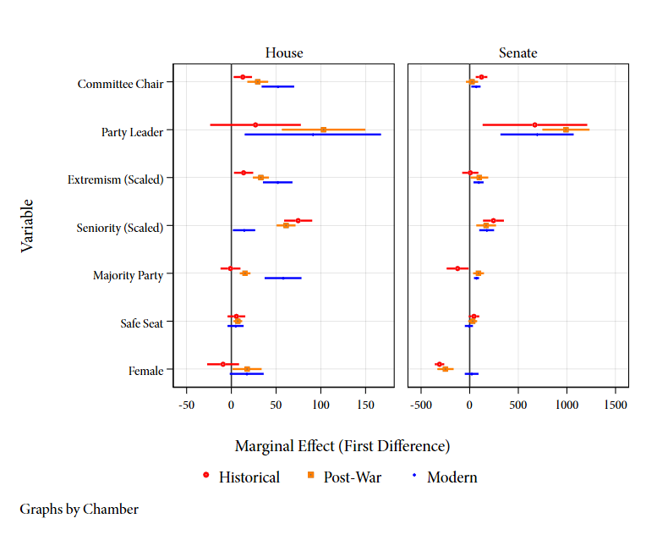

*Note*: The marginal effect of each variable (i.e. the change in the expected number of speeches) is shown. For binary variables, the effect is the change from one to zero. For continuous variables, the effect is the change from one standard deviation below the mean to one standard deviation above the mean. All other covariates are held at their observed values. The six regressions are estimated by subsetting the data by chamber and period as defined in the main text. The 95% confidence intervals are shown.

# Country-Specific Results: Polarization

From the above analysis, one interesting implication relates to polarization and its effect on legislative speech. It is widely agreed (e.g. McCarty, Poole, and Rosenthal 2016) that the House of Representatives has become more polarized along partisan lines over the period under consideration, with the peak arguably occurring during the "Modern" period (1995-present day). Therefore, it is interesting to note that the effect of political variables is similarly *increasing* in more modern periods. Specifically, note that in the House of Representatives—but not the Senate, the effect of committee chair, being in the majority party, and ideological extremism have all increased in each successive period. Further, seniority—reflecting perhaps some "non-partisan" expertise—has decline in its importance in each successive period.

We test this more systematically by examining whether it corresponds to increasing polarization. Focusing on the final two periods pooled together (1945-2010; Post War and Modern), we interact our explanatory variables with a standard measure of polarization (difference in party means, see McCarty, Poole, and Rosenthal 2016).[11] This measure is standardized such that zero is the least polarized Congress in the period (90th House [1967-1968]; 78th Senate [1943-1944]) and one is the most polarized (109th House [2005-2006]; 111th Senate [2009-2010]). Figure 5 shows the trajectory of this measure over time and across chamber.

**Figure 5: Trends in Polarization**

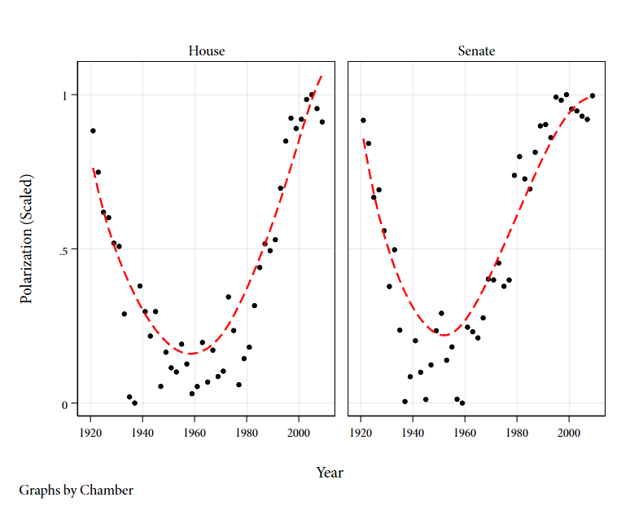

*Note*: This table reports the trajectory of polarization, as defined in the main text, by chamber across the post-war period.

Figure 6 reports the results of the interactive specification; it shows the interaction coefficient on polarization and each of the key explanatory variables from earlier. A significant coefficient represents evidence of the covariate increasing (decreasing) as polarization increases (decreases).

**Figure 6: Varying Effects of Polarization**

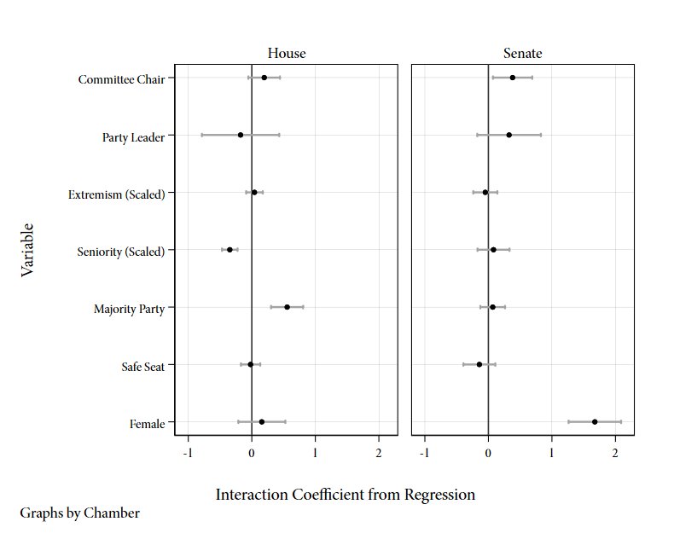

*Note*: This table reports a subset of coefficients from a model that interacts polarization (as defined in the main text) with all of the explanatory variables. Each coefficient shown represents the interaction term between polarization and the underlying variable. 95% confidence intervals are reported.

The results provide some evidence of the importance of polarization. The evidence is clearer for the House: Two key variables (seniority, majority party status) show the expected effect where seniority becomes less important and majority party membership becomes more important in more polarized periods. In the Senate, we see some evidence for an increasing effect of committee chair and a much larger effect for women (i.e. women speak more in a polarized Senate). The effect on gender (less negative in both chambers) might be attributable to polarization, but it seems more driven by the fact that the number of female members is markedly higher in periods of higher polarization (modern era).[12] Interestingly, there does not appear to be a change in the effect of ideological extremism suggesting that the changes noted in Figure 4 might be attributed to other temporal trends.

# Conclusions

Overall, this chapter provides the first systematic analysis of the political determinants of floor speech in the United States Congress from 1921 to 2010. Unlike existing analyses, we are able to examine a nearly complete set of floor speeches and look at activity in both the House and Senate. Our results are mostly descriptive, but provide an interesting set of results that complements the growing literature on (mostly) European parliamentary debates. We find that members who are endowed with special institutional or political responsibilities (committee chairs, ranking members, and party leaders) take the floor decidedly more than their backbench colleagues. This pattern persists throughout all historical periods and across both chambers. More subtly, we find that in the more majoritarian orientated House, ideological extremism, majority party status and seniority all correspond to more activity. The Senate shows somewhat more inconsistent results, although the effect of seniority also persists.

Looking across time, it appears that the effect of some variables (seniority, extremism, and gender) has changed while others (e.g. party leadership) remain unchanged. Exploring the determinants of these effects and whether there are certain sub-groups with systematically different relationships remain important areas for future research.

Overall, there are two takeaways from this analysis. First, scholars of legislative politics should take advantage of the rich availability of the content and volume of floor speeches for most of American history to test various theoretical questions. It allows researchers to expand beyond the (important) analysis of floor votes and look at the actual content of policy debates and what that reveals about American political institutions, behavior, and development. Second, the fact that the theoretical lens from European legislative studies seems to have some explanatory power in the United States provides an interesting area for future research. While we have focused mostly on individual-centered determinants of speech making, exploring whether other aspects of the European theoretical analysis (e.g. party coalition dynamics; Martin and Vanberg 2008) also are supported by the data is an important area of future research. It further allows theories tested in the United States with its unique data availability and historical variation to help build more general theories of legislative debates that could, themselves, be tested in European cases.

# References

Aldrich, John H., and David W. Rohde. 2000a. *The Logic of Conditional Party Government: Revisiting the Electoral Connection*. PIPC.

Aldrich, John H., and David W. Rohde. 2000b. “The Republican Revolution and the House Appropriations Committee.” *The Journal of Politics* *62* (1): pp. 1–33.

Aldrich, John H., Mark M. Berger, and David W. Rohde. 1999. *The Historical Variability in Conditional Party Government, 1877-1986*. Michigan State University.

Anzia, Sarah F., and Christopher R. Berry. 2011. “The Jackie (and Jill) Robinson Effect: Why Do Congresswomen Outperform Congressmen?” *American Journal of Political Science* *55* (3): pp. 478–493.

Brady, David W., Joseph Cooper, and Patricia A. Hurley. 1979. “The Decline of Party in the US House of Representatives, 1887-1968.” *Legislative Studies Quarterly* *4* (3): pp. 381–407.

Burstein, Paul, Shawn Bauldry, and Paul Froese. 2005. “Bill Sponsorship and Congressional Support for Policy Proposals, from Introduction to Enactment or Disappearance.” *Political Research Quarterly* *58* (2): pp. 295–302.

Canon, Garrison Nelson, David, and Charles Stewart III. 2002. “Historical Congressional Standing Committees, 1st to 79th Congresses, 1789-1947 [House].”

Cavanagh, Thomas E. 1979. “Rational Allocation of Congressional Resources: Member Time and Staff Use in the House.” In *Public Policy and Public Choice,* edited by Douglas W. Ray, and Theodore J. Eismeier, pp. 209–47. Beverly Hills: Sage Publications.

Clinton, Joshua, Simon Jackman, and Douglas Rivers. 2004. “The Statistical Analysis of Roll Call Data.” *American Political Science Review* *98* (2): pp. 355–370.

Connor, George E., and Bruce I. Oppenheimer. 1993. “Deliberation: An Untimed Value in a Timed Game.” In *Congress Reconsidered*, edited by Lawrence C. Dodd, and Bruce I. Oppenheimer, pp. 315–30. Washington, DC: CQ Press.

Cooper, Joseph, and David W Brady. 1981. “Institutional Context and Leadership Style: The House from Cannon to Rayburn.” *American Political Science Review* 75(2): 411–25.

Cooper, Joseph, and Cheryl D. Young. 1989. “Bill Introduction in the Nineteenth Century: A Study of Institutional Change.” *Legislative Studies Quarterly* *14* (1): pp. 67–105.

Cox, Gary W., and Mathew D. McCubbins. 2005. *Setting the Agenda: Responsible Party Government in the US House of Representatives*. Cambridge; New York: Cambridge University Press.

Cox, Gary W., and Mathew D. McCubbins. 2007. *Legislative Leviathan: Party Government in the House*. Cambridge; New York: Cambridge University Press.

Cox, Gary W., and Keith T. Poole. 2002. “On Measuring Partisanship in Roll-Call Voting: The US House of Representatives, 1877-1999.” *American Journal of Political Science* *46* (3): pp. 477–489.

Davidson, Roger H., Walter J. Oleszek, Frances E. Lee, and Eric Schickler. 2013. *Congress and Its Members*. Congressional Quarterly Press.

Davis, Christopher M. 2019. *The Legislative Process on the House Floor: An Introduction*. Congressional Research Service. Report.

Duverger, Maurice. 1963. *Political Parties: Their Organization and Activity in the Modern State*. New York: Wiley.

Fenno, Richard F. 1973. *Congressmen in Committees*. Little, Brown and Company.

Fenno, Richard F. 1977. “U.S. House Members in Their Constituencies: An Exploration.” *American Political Science Review* *71* (3): pp. 883–917.

Fenno, Richard F. 1978. *Home Style: Representatives in Their Districts*. Boston: Little, Brown.

Gamm, Gerald, and Kenneth Shepsle. 1989. “Emergence of Legislative Institutions: Standing Committees in the House and Senate, 1810-1825.” *Legislative Studies Quarterly* *14* (1): pp. 39–66.

Gelman, David A. 2018. “Ideology and Participation: Examining the Constitutional Convention of 1787.” *Political Research Quarterly 71* (3): pp. 546–559.

Gentzkow, Matthew, Jesse M. Shapiro, and Matt Taddy. 2018. “Congressional Record for the 43rd-114th Congresses: Parsed Speeches and Phrase Counts.” <https://data.stanford.edu/congress_text>. Palo Alto, CA: Stanford Libraries.

Gilligan, Thomas W., and Keith Krehbiel. 1987. “Collective Decisionmaking and Standing Committees: An Informational Rationale for Restrictive Amendment Procedures.” *Journal of Law, Economics, & Organization* *3* (2): pp. 287–335.

Gilligan, Thomas W., and Keith Krehbiel. 1990. “Organization of Informative Committees by a Rational Legislature.” *American Journal of Political Science 34* (2): pp. 531–564.

Hall, Richard L. 1996. *Participation in Congress*. New Haven: Yale University Press.

Harris, Douglas B. 2005. “Orchestrating Party Talk: A Party-Based View of One-Minute Speeches in the House of Representatives.” *Legislative Studies Quarterly* *30* (1): pp. 127–141.

Heitshusen, Valerie. 2019. *The Legislative Process on the Senate Floor: An Introduction*. Congressional Research Service. Report.

Hill, Kim Quaile, and Patricia A Hurley. 2002. “Symbolic Speeches in the US Senate and Their Representational Implications.” *The Journal of Politics* *64* (1): pp. 219–231.

History, U.S. House of Representatives, Art & Archives. 2017a. “Democratic Whips (1899 to Present).”

History, U.S. House of Representatives, Art & Archives. 2017b. “Majority Leaders (1899 to Present).”

History, U.S. House of Representatives, Art & Archives. 2017c. “Minority Leaders (1899 to Present).”

History, U.S. House of Representatives, Art & Archives. 2017d. “Republican Whips (1897 to Present).”

Hudiburg, Jane A. 2019. *Suspension of the Rules: House Practice in the 114th Congress (2015-2016)*. Congressional Research Service. Report.

Inter-University Consortium for Political Science Research (ICPSR), and Carolll McKibbin. 1997. “Roster of United States Congressional Officeholders and Biographical Characteristics of Members of the United States Congress, 1789-1996: Merged Data.” <https://doi.org/10.3886/ICPSR07803.v10>.

Jenkins, Jeffery A., and Charles Stewart III. 2012. *Fighting for the Speakership: The House and the Rise of Party Government*. Princeton, N.J.: Princeton University Press.

Karpowitz, Christopher F., Tali Mendelberg, and Lee Shaker. 2012. “Gender Inequality in Deliberative Participation.” *American Political Science Review* *106* (3): pp. 533–547.

Kessler, Daniel, and Keith Krehbiel. 1996. “Dynamics of Cosponsorship.” *American Political Science Review* *90* (3): pp. 555–566.

Koger, Gregory. 2003. “Position Taking and Cosponsorship in the US House.” *Legislative Studies Quarterly* *28* (2): pp. 225–246.

Krehbiel, Keith. 1993. “Where’s the Party?” *British Journal of Political Science* *23* (2): pp. 235–266.

Krehbiel, Keith, Kenneth A. Shepsle, and Barry R. Weingast. 1987. “Why Are Congressional Committees Powerful?” *American Political Science Review* *81* (3): pp. 929–45.

Langbein, Laura I., and Lee Sigelman. 1989. “Show Horses, Work Horses, and Dead Horses.” *American Politics Research* *17* (1): pp. 80–95.

Lewis, Jeffrey B., Keith Poole, Howard Rosenthal, Adam Boche, Aaron Rudkin, and Luke Sonnet. 2020. “Voteview: Congressional Roll-Call Votes Database.” <https://voteview.com>.

Maltzman, Forrest. 1998. *Competing Principals: Committees, Parties, and the Organization of Congress*. Ann Arbor, Mich.: University of Michigan Press.

Maltzman, Forrest, and Lee Sigelman. 1996. “The Politics of Talk: Unconstrained Floor Time in the US House of Representatives.” *The Journal of Politics* *58* (3): pp. 819–830.

Martin, Lanny W, and Georg Vanberg. 2008. “Coalition Government and Political Communication.” *Political Research Quarterly* *61* (3): pp. 502–516.

Matthews, Donald R. 1959. “The Folkways of the United States Senate: Conformity to Group Norms and Legislative Effectiveness.” *American Political Science Review* *53* (4): pp. 1064–1089.

Mayhew, David R. 1974. *Congress: The Electoral Connection*. New London: Yale University Press.

McCarty, Nolan, Keith T. Poole, and Howard Rosenthal. 2001. “The Hunt for Party Discipline in Congress.” *American Political Science Association* *95* (3): pp. 673–687.

McCarty, Nolan M., Keith T. Poole, and Howard Rosenthal. 2016. *Polarized America: The Dance of Ideology and Unequal Riches*. Cambridge, Massachusetts; London, England: The MIT Press.

Morris, Jonathan S. 2001. “Reexamining the Politics of Talk: Partisan Rhetoric in the 104th House.” *Legislative Studies Quarterly* *26* (1): pp. 101–121.

Nelson, Garrison. 1993. “Committees in the U.S. Congress, 1947-1992.” Washington, D.C.: Congressional Quarterly.

Nokken, Timothy P., and Keith T. Poole. 2004. “Congressional Party Defection in American History.” *Legislative Studies Quarterly* *29* (4): pp. 545–568.

Owens, John E., Scot Schraufnagel, and Quan Li. 2016. “Assessing the Effects of Personal Characteristics and Context on U.S. House Speakers’ Leadership Styles, 1789-2006.” *SAGE Open* *6* (2): pp. 1–14.

Palmer, Betsy. 2010. *Special Order Speeches and Other Forms of Non-Legislative Debate in the House*. Congressional Research Service. Report.

Pearson, Kathryn, and Logan Dancey. 2011. “Speaking for the Underrepresented in the House of Representatives: Voicing Women’s Interests in a Partisan Era.” *Politics & Gender* *7* (4): pp. 493–519.

Poole, Keith T. 2005. *Spatial Models of Parliamentary Voting*. Cambridge; New York: Cambridge University Press.

Poole, Keith T., and Howard Rosenthal. 1985. “A Spatial Model for Legislative Roll Call Analysis.” *American Journal of Political Science 29* (2): pp. 357–384.

Poole, Keith T., and Howard Rosenthal. 1991. “Patterns of Congressional Voting.” *American Journal of Political Science 35* (1): pp. 228–278.

Poole, Keith T., and Howard Rosenthal. 2007. *Ideology and Congress: A Political Economic History of Roll Call Voting*. Somerset: Taylor & Francis Group.

Poole, Keith T, Jeffrey B. Lewis, James Lo, and Royce Carroll. 2011. “Scaling Roll Call Votes with W-NOMINATE in R.” *Journal of Statistical Software* *42* (14): pp. 1–21.

Proksch, Sven-Oliver, and Jonathan B. Slapin. 2012. “Institutional Foundations of Legislative Speech.” *American Journal of Political Science* *56* (3): pp. 520–537.

Proksch, Sven-Oliver, and Jonathan B. Slapin. 2015. *The Politics of Parliamentary Debate*. Cambridge: Cambridge University Press.

Ripley, Randall B. 1967. *Party Leaders in the House of Representatives*. Washington: Brookings Institution.

Rocca, Michael S. 2007. “Nonlegislative Debate in the U.S. House of Representatives.” *American Politics Research* *35* (4): pp. 489–505.

Rohde, David W. 1991. *Parties and Leaders in the Post-Reform House*. Chicago; London: The University of Chicago Press.

Sinclair, Barbara. 1983. *Majority Leadership in the U.S. House*. Johns Hopkins University Press.

Sinclair, Barbara. 1986. “The Role of Committees in Agenda Setting in the U.S. Congress.” *Legislative Studies Quarterly* *11* (1): pp. 35–45.

Sinclair, Barbara. 1989. *The Transformation of the US Senate*. Baltimore: Johns Hopkins University Press.

Sinclair, Barbara. 1998. *Legislators, Leaders, and Lawmaking: The US House of Representatives in the Post-Reform Era*. Baltimore: Johns Hopkins University Press.

Snyder, James M, Jr., and Tim Groseclose. 2000. “Estimating Party Influence in Congressional Roll-Call Voting.” *American Journal of Political Science* *44* (2): pp. 193–211.

Stewart III, Charles, and Jonathan Wood. 2016. “Congressional Committee Assignments, 103rd to 114th Congresses, 1993–2017 [House].”

Strahan, Randall. 2007. *Leading Representatives: The Agency of Leaders in the Politics of the US House*. Baltimore: Johns Hopkins University Press.

Taylor, Andrew J. 2012. *The Floor in Congressional Life*. Ann Arbor: University of Michigan Press.

Weingast, Barry R. 1989. “Floor Behavior in the US Congress: Committee Power Under the Open Rule.” *American Political Science Review* *83* (3): pp. 795–815.

Weingast, Barry R., and William J. Marshall. 1988. “The Industrial Organization of Congress; or, Why Legislatures, Like Firms, Are Not Organized as Markets.” *Journal of Political Economy* *96* (1): pp. 132–163.

Wilson, Rick K., and Cheryl D. Young. 1997. “Cosponsorship in the US Congress.” *Legislative Studies Quarterly* *22* (1): pp. 25–43.

Wilson, Woodrow. 1885. *Congressional Government: A Study in American Politics*. Boston: Mifflin Houghton.

Wirls, Daniel. 2007. “The “Golden Age” Senate and Floor Debate in the Antebellum Congress.” *Legislative Studies Quarterly* *32* (2): pp. 193–222.

Woon, Jonathan. 2008. “Bill Sponsorship in Congress: The Moderating Effect of Agenda Positions on Legislative Proposals.” *The Journal of Politics* *70* (1): pp. 201–216.

1. Article I, section 5 of the U.S. Constitution states that "Each House may determine the Rules of its Proceedings". The only exceptions to this are the rules regarding the number of members that constitute a quorum and the number of members needed to approve for the calling of years and nays (also in Article I, section 5.)
2. At the start of this project, this dataset was unavailable and our own independently parsed version returns very similar counts. We rely on their dataset to facilitate replication.
3. Though Independents occasionally win office, they typically still caucus with one of the two parties.
4. Starting in the 66th Congress (1919-1920), all classes of sitting Senator had been chosen by direct election after the ratification of the 17th Amendment began nationwide elections for Senators starting in 1913.
5. They provide extensive documentation of their approach; the key strategy uses the fact that speeches by members are listed with their name and possibly state in all capital letters (e.g. "Mr. SMITH", "Mr. JOHN SMITH", "Mr. SMITH of Maryland"). By looking for these names as starting speeches and taking the text between them as, with some exceptions, constituting a single speech, it is possible to construct the corpus of speeches and match the individuals to serving members.
6. Committee appointment and leadership data come from Charles Stewart and co-authors (Canon and Stewart III 2002; Nelson 1993; Stewart III and Wood 2016).
7. Party leadership positions include the Majority and Minority leaders and majority and minority Whips. Data on House party leaders comes from the U.S. House Office (History 2017a, 2017b, 2017c, 2017d) and the Stewart et al. data noted previously.
8. We define "Exposure" using two measures, as it is difficult to get exact time served for the nearly 90 year period considered; first, we use the data provided by the ICPSR (ICPSR and McKibbin 1997) to get the time served for members before 1996. We calculate a measure for the entire period using the time between the first and last roll call vote that a member participated in using data from Lewis et al. (2020). After normalizing by the total available time, we take the larger value of the two.
9. We exclude all members elected by special election in the multivariate analysis. This is for two reasons; first, their measure of electoral vulnerability may be an imprecise measure of the true marginality of the district; second, as they typically serve for short periods of time, their observed speech counts are likely biased downwards.
10. The effects are calculated by holding all other covariates constant for each observation, changing the variable of interest, and averaging over observations. It is thus an "average marginal effect".
11. Specifically, we take the "raw" measure to be the (absolute) value of the difference between the mean ideal point of Democrats from the mean ideal point of Republicans. We then linearly scale this measure to be "one" for the most polarized Congress and "zero" for the least polarized Congress for the House and Senate, separately, to allow for easy interpretation.
12. The correlation between the proportion of female members and the measure of polarization is .96 in the House and .69 in the Senate.